


Student Name:

Student ID :

Unit/Module : Marketing Essentials

Programme :

_______________________________________________________

Nelson College London

1

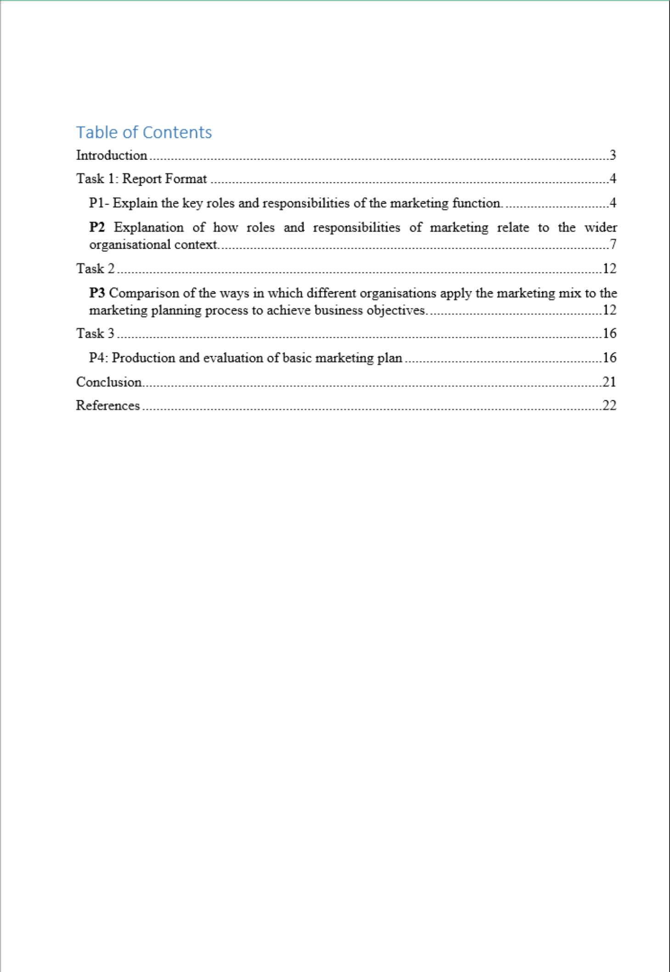

2

Introduction

Marketing is the basic function for every organization. Marketing deals with the customers who are the lifeblood of the company. If the company can’t attract customers, it can’t be successful organization. Marketing is the function of attracting the customers to the company and selling the products to the customers and making good relationship with the target group of customers (Botin, 2009).

H&M is the world renowned clothe company and it produces and sells high quality clothes to the world customers. The company H&M is customer oriented and always focuses on the demands of the customers. The marketing managers of the H&M research the market and understand what the customers expect and then produce clothes according to the expectations of the customers. The customers of the company are motivated to build long term relationship with the company by the marketing function. All functions of the company are interrelated and influence each other. The marketing plan and marketing mix strategy are formulated for achieving the business objectives of the company.

3

Task 1: Report Format

Date: 2-12-2018

To: CEO, H&M

From: Assistant Marketing Manager, H&M

Dear Sir,

The roles and responsibilities of the marketing functions in case of H&M are explained in the following section.

P1- Explain the key roles and responsibilities of the marketing function.

H&M is a Swedish multinational company that is the cloth retailer. The company was established in 1947. There are 4200 stores in 62 countries of H&M. The number of employees in H&M is 135000.

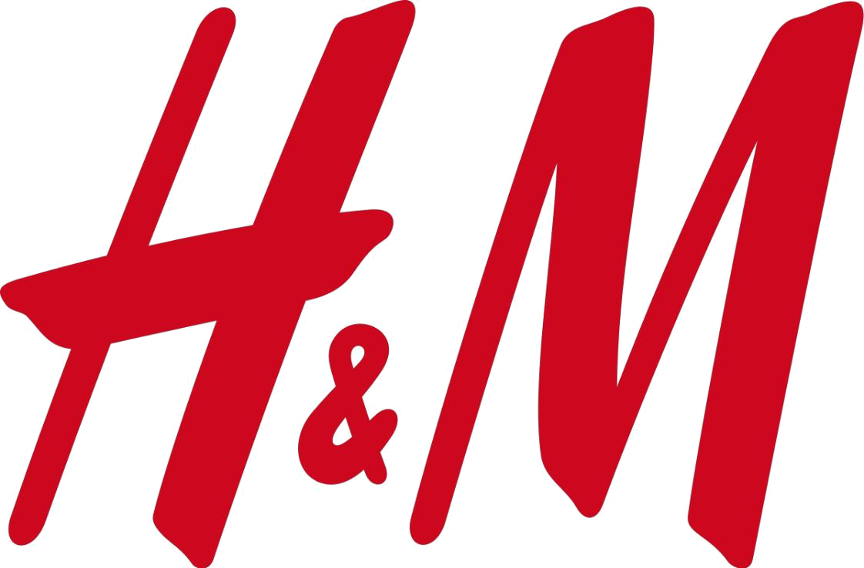

Carothers (2011) stated that marketing is the process of encouraging the customers to buy the products of the company and of building relationship with customers. The marketing process
4

is applied in the organization for attracting the customers and prospects to the company and for retaining the customers for lifetime.

Chartered Institute of Marketing states that marketing is the system of identifying the customers and satisfying the demands of the customers profitably (Haldar, 2010).

American Marketing Association communicate marketing offerings customers (Haldar, 2010).

states that marketing is the set of activities that create and to the customers and build good relationship with the

Current and future marketing trends

The current marketing trends focus on the demands and needs of the customers. The marketing managers of the company emphasis on the development of products that are demanded by the customers. Recently, the marketing also gives importance on internal marketing and on better relationship building with employees and customers. The future marketing trends may focus on the holistic approach and holistic demands. The societal marketing concept may be applied in future. The marketers may see the interests of the society in a whole.

The key roles of marketing functions of H&M

Market analysis

Market analysis is the very important task of the marketing manager of the H&M. The market analysis helps the H&M to take the effective business strategy for achieving the business objectives. The market analysis also contributes to develop the products that can properly meet the various demands of the customers.

5

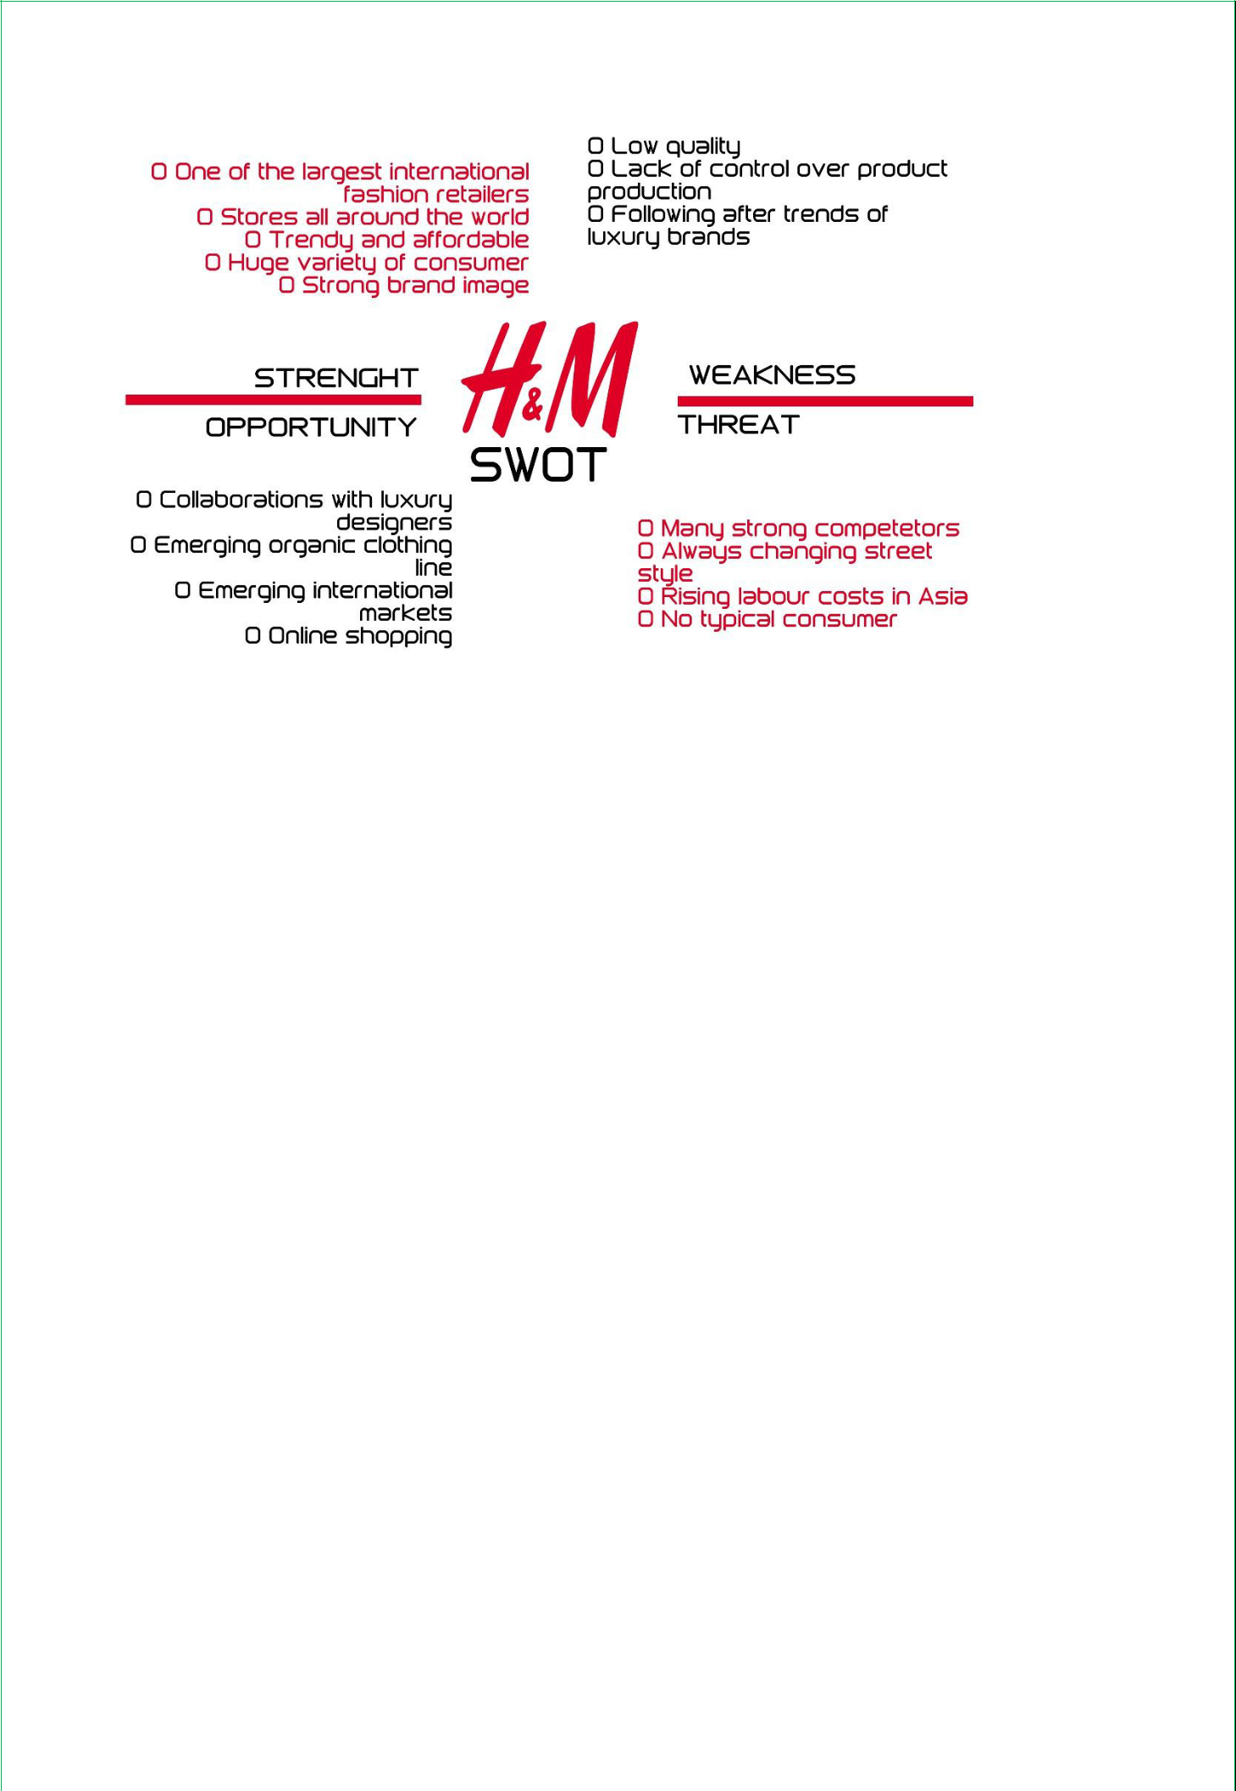

Figure: SWOT analysis of H&M (Rouse, 2009).

Selecting the target market

The target market is selected by the marketing managers of the H&M. The marketing managers divide the market and then select the segment where the clothes of the H&M can be solved. There are mainly four targeting strategies such as differentiating, undifferentiated, local and niche marketing strategy. H&M follows differentiated marketing strategy and satisfies the demands of the customers of each segment in different ways.

Positioning is the activity of capturing the minds and hearts of the customers by the product and service quality of the company.

Developing marketing mix

The marketing mix is made up with the controllable marketing elements. The elements of marketing mix are product, price, place and promotion. Marketing function of H&M develops the marketing strategies and implements the strategies. The products of H&M are the clothes of different sizes, colours and designs for the different types of the customers.

6

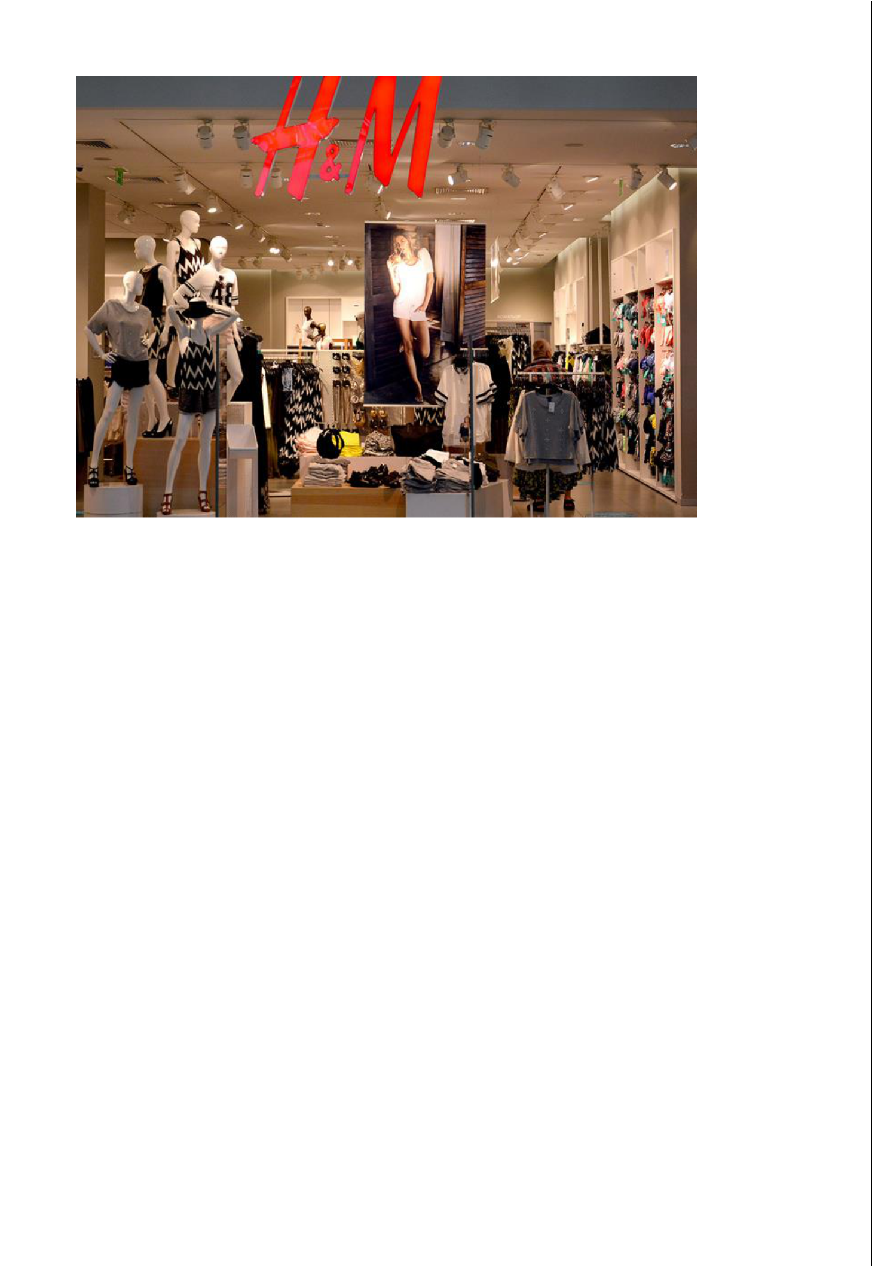

The company H&M uses market penetration pricing strategy so that every customers of the company can afford to buy the clothes of the company. Promotion activities are performed through sponsorship, event management and advertising. The clothes of H&M are made available to the nearest location of the customers through the right distribution strategy (Dawkins, 2007).

Implementation and control of the marketing functions

Implementation indicates the performing of the marketing activities properly and in the right ways. The marketing functions are performed for delivering the best value to the customers of H&M and to satisfy the demands of the customers in satisfactory way. The marketing managers of H&M use sales analysis and marketing share analysis for controlling the marketing functions.

P2 Explanation of how roles and responsibilities of marketing relate to the wider organisational context.

7

Overview of Marketing process of H&M

Marketing process is the systematic approach for identification of the customers and their needs and developing of products and services to satisfy the customers and to retain the customers through building up better relationship. The marketing process starts with the identification of the customers of the H&M and finishes with the building of strong and long-term relationship with the target customers of the company. Through the marketing process the marketing managers of H&M target the customers and produce clothes based on the design and color and size requirements of the customers and make profitable and strong customer relationship.

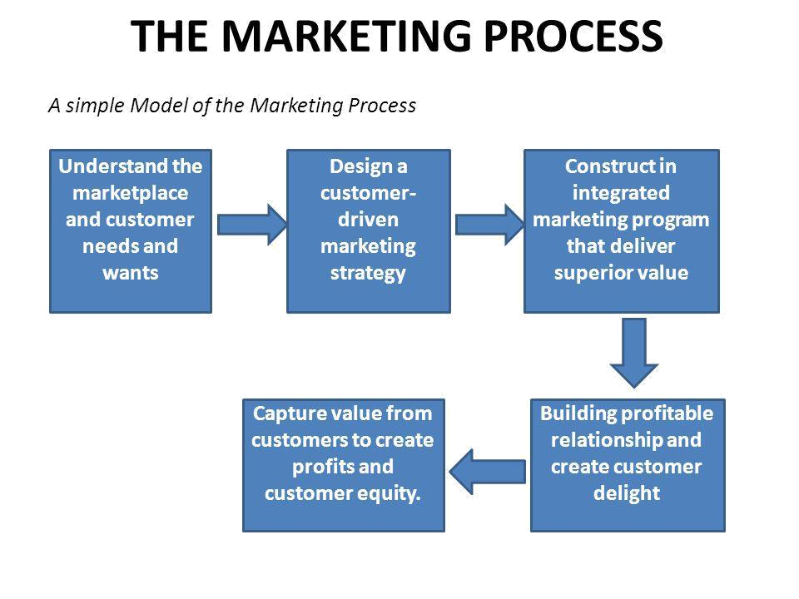

Figure: Marketing process of H&M (Díaz-Maggioli, 2004)

Marketing Functions of the H&M

The employees and people of the H&M perform different functions such as management, finance, marketing, HR and customer service.

Management is the function of managing the resources like money and the people of H&M in properly. The management of H&M ensures the maximum uses of the resources to achieve the goals and objectives of the company.

8

Finance is the function of collecting money for the H&M from different sources and distributing the money to the different departments of the company so that the functions of H&M are performed properly for achieving the objectives.

HR is the activity of recruiting the energetic and skilled employees for the H&M. The HR managers hire the best employees who have skill and passion for working in H&M.

Customer service is the activity of contacting with the customers and solving the problem of the customers. The customer service people of H&M call over the telephone to the customers and know their satisfaction or dissatisfaction and then try to solve the problems of the customers of H&M.
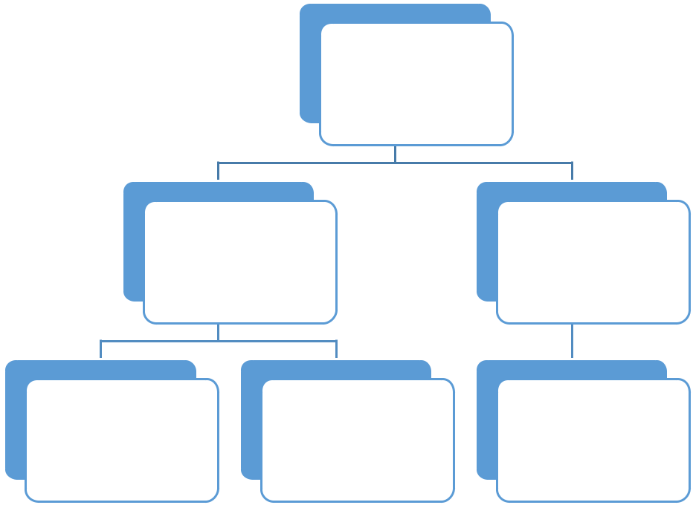

Functions of
the
organization

Management Marketing

Service people Finance HR

Figure: Functions of the organization (Díaz-Maggioli, 2004)

Interrelationship between the marketing function and other functions of H&M

Marketing is the center of all functions and it is related with each function of the H&M. The management develops policies and strategies of the H&M and the marketing people implement the policy. The marketing managers contribute in producing effective business strategy for H&M and help the managers by providing suggestions and information. The finance department of H&M provides money to the marketing department and contributes in performing the marketing functions timely and properly. The marketing helps the finance

9

department to prepare right budget for the company and to collect money from the lowest cost sources. The HR people of H&M contribute in marketing by hiring skilled and well-mannered marketing employees and by making the employees skilled and experienced. The marketing people help the HR managers of H&M by giving information about job description and job requirement and the number of vacancies in the marketing department. The marketing people suggest the service people of H&M how to talk with the customers in friendly way and how to attract the customers to the clothes of the H&M. The service people also help the marketing function by providing information about the customer requirement. So, the functions of the H&M are interrelated and the objectives of the company can be achieved by performing the activities properly (Rayner and Cools, 2012).

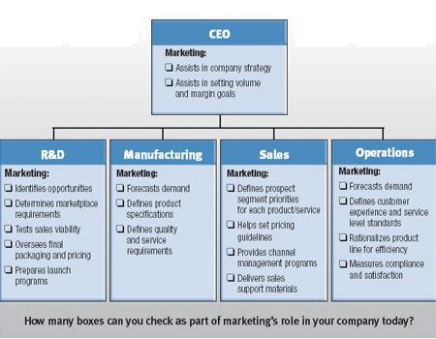

Figure: Interrelationship of marketing with other departments (Rayner and Cools, 2012).

Roles of marketing in B2B context:

- Business customer identification: Business customer identification is the first task of marketing manager of H&M in the B2B context. The marketing managers of H&M search for the retailers and wholesalers and then select the retailers who have goodwill in the market.

10

- Delivering clothes properly: The delivery of the products to the business customers is required for achieving the marketing objective of H&M. The marketing people of H&M properly manage the supply and delivery of the clothes to the business customers like retailers.

- Promoting the products of H&M to business customers: The marketing of H&M promotes the clothes of the H&M to the retailers and wholesalers. For example, trade promotions such as trade discount of 5% is offered to the business customers so that

the customers buy the clothes and sell the clothes to the final customers (Reeves, 2010).

Roles of marketing in B2C context:

- Satisfying the demands of the customers: The customer satisfaction ensures the success of the company. The marketing people of H&M develop value proposition that can satisfy the customer demands and can encourage the customers to buy again.

- Promoting the products to the customers: Promotion of clothes and products is must because the promotion induces the customers to buy the clothes of the H&M. The marketing managers apply different techniques such as advertising and sales promotion for inducing the customers (Rouse, 2009).

- Building long term relationship: The marketing people of H&M develop profitable customer relationship and this is required for reaching to the destination of the H&M. The relationship encourages to rebuy the clothes from H&M.

The Relevant market in the context to H&M:

B2C market is the relevant market context for H&M because H&M is selling huge number of products & services to the ultimate consumers through online & using other means. They have huge customers bases & outlets through which they are providing their products & services to their customers.

11

Task 2

Date: 2-12-2018

To: CEO, H&M

From: Assistant Marketing Manager, H&M

Dear Sir,

Different organizations use marketing mix strategies in different ways. The application of marketing mix elements in H&M and in Zara is compared here.

P3 Comparison of the ways in which different organisations apply the marketing mix to the marketing planning process to achieve business objectives.

Marketing mix consists of the tools and techniques that the organizations like H&M can control and can modify according to the situation of the company and market. H&M develops marketing mix strategy so that the company can reach to the customers with the quality clothes at the right and can influence the customers to buy the clothes of the company (Ellson, 2004).

The marketing mix elements are the product, price, place and promotion. These 4ps are mainly called marketing mix. There are other 3ps such people, process and physical evidence. The 7ps make the extended marketing mix strategy. When the additional 3ps are added to the main 4ps of the marketing mix, it is called extended marketing mix.

The extended marketing mix elements are explained and applied in H&M

12

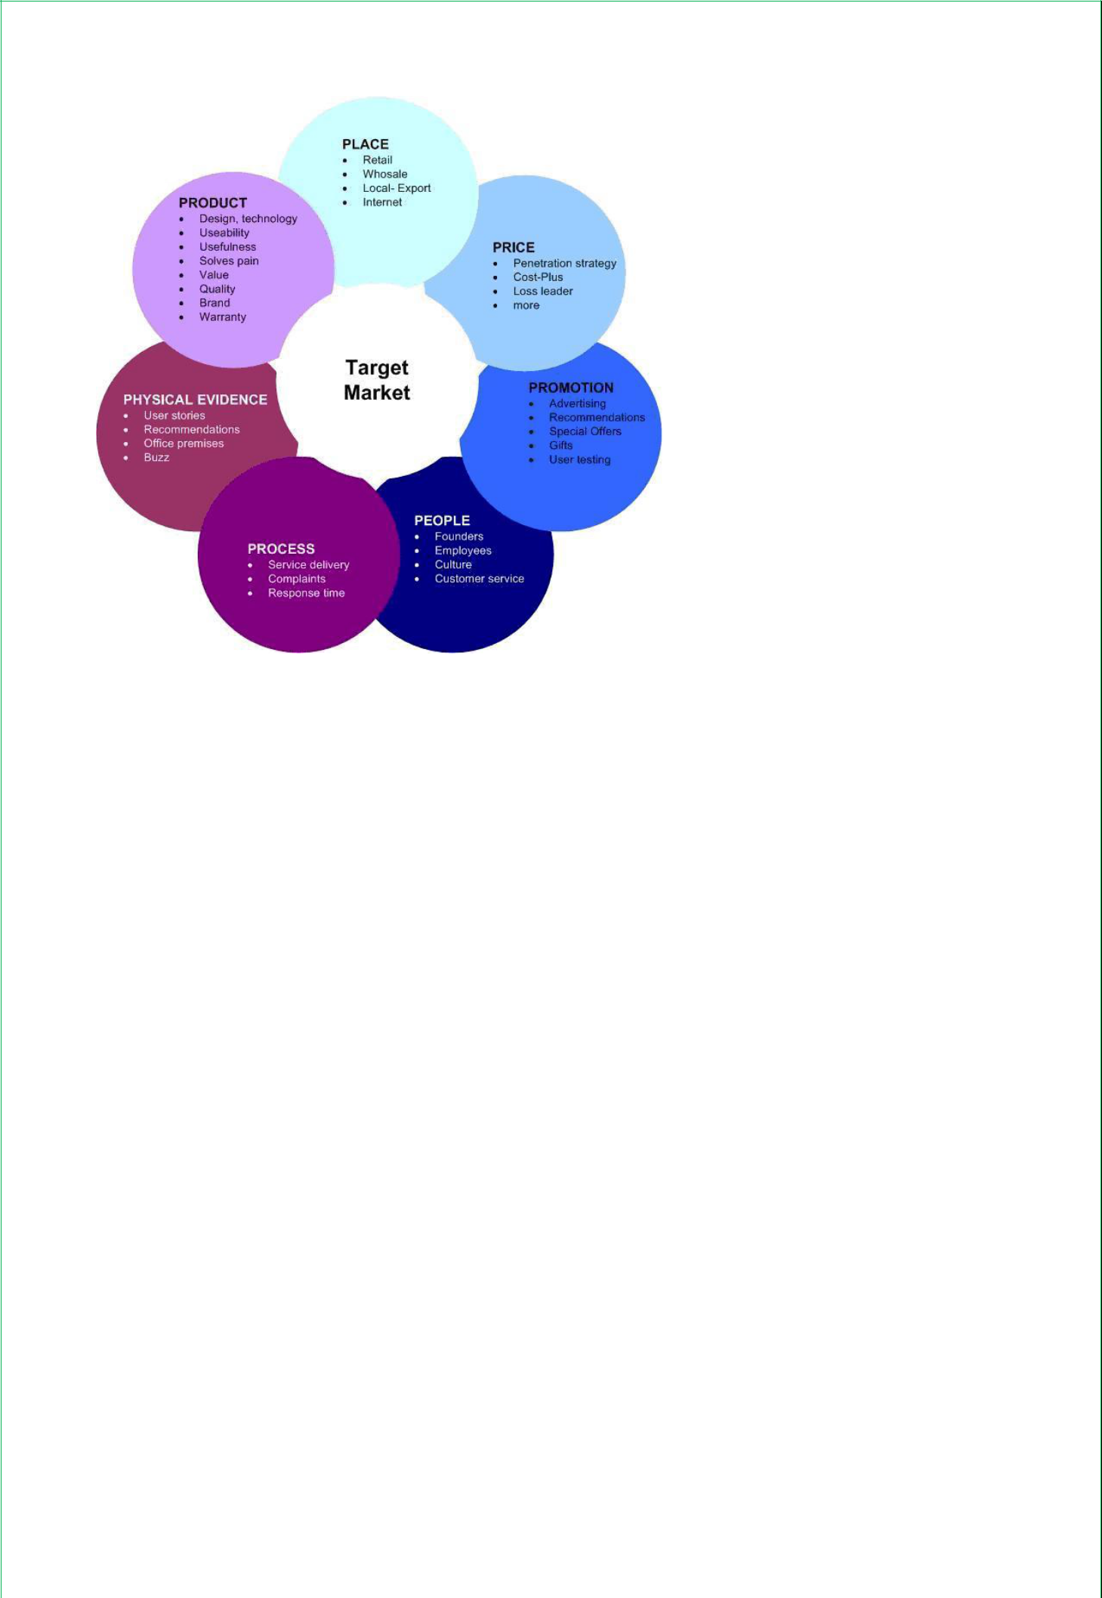

Figure: Marketing mix elements (Eddy, 2014).

Product

H&M always focus on the quality of the products. The clothes such as shirts and pants and baby dress are produced based on the customer demands. The marketing people of H&M conduct marketing research for knowing what kind of clothes and what designs and what colours the customers prefer and based on the marketing research information the company produces clothes.

Price

Price is the value of the products that the customers pay to the company for getting the products. The marketing objectives of the H&M is to expand its market share and to increase the customers. To achieve the marketing objective, the company set prices of the clothes that are affordable by the customers. The company mainly follow market penetration pricing strategy.

Place

Place is the distribution of the products and the availability of the products. The place strategy indicates where the products of the company are available and from where the customers can

13

buy the products of the company. The marketing managers of H&M takes extensive distribution strategy for making the clothes available to the customers.

Promotion

Promotion is the performance of informing the customers about the products of the company through advertising, personal selling, direct marketing and online marketing strategy. To promote the products of the H&M, the marketing people use advertising, sales promotion and personal selling techniques (Ellson, 2004).

People

The people of the company interacts with the customers and they take part in the production of the clothes and so, the people contribute much in satisfying the customers and in achieving the objectives of the company. The people such as designers, marketing employees and others are experienced.

Process

The process of the system of delivery of the products that the company uses for distributing the products to the customer destination. H&M uses own transportation system for delivering the clothes to the customers who buy the clothes.

Physical evidence

Physical evidence is the elements that are used for making the services tangible to the customers. The stores of the H&M are designed attractively so that the customers feel good in the stores and are motivated to buy the clothes of the company (Rivera, 2007).

Difference between the marketing mix application of H&M and Zara.

Marketing mix elements | Application of marketing mix |  | Application of marketing mix
 | in H&M |  | in Zara
Product | The product mix of H&M |  | Zara produces clothes of high
 | consists of the different types |  | quality for men and women
 | of clothes such as men clothes, |  | customers. | Through | the
 | children clothes and | women | product strategy, Zara satisfies
 | clothes. The product | strategy | the customer needs properly.
 | 14

 | contributes is satisfying the all
 | customers
Price | In case of pricing the H&M |  |  |  |  |  |  | Zara has objective of achieving
 | uses | market |  |  | penetration |  |  | higher profit and to achieve
 | pricing strategy and this helps |  |  |  |  |  |  | this | objective, | the | company
 | to achieve |  |  | the |  | objective |  | uses | marketing |  | skimming
 | acquiring |  | more |  |  | customers |  | pricing strategy
 | (Franklin, 2013).
Place | The objective of H&M is to |  |  |  |  |  |  | Zara uses selective distribution
 | reach to all customers and for |  |  |  |  |  |  | strategy to reach to the
 | this | the |  | company |  |  | uses | customers who agree to buy
 | extensive distribution strategy |  |  |  |  |  |  | quality clothes at higher price
Promotion | To achieve the objective of |  |  |  |  |  |  | Zara uses advertising, e-mail
 | achieving |  |  | 10% |  | more |  | marketing and sponsorship for
 | customers every month, H&M |  |  |  |  |  |  | achieving the |  | objective |  | of
 | uses extensive advertising and |  |  |  |  |  |  | reaching to the customers who
 | social | media |  |  |  | promotion |  | are willing to buy the clothes of
 | techniques. |  |  |  |  |  |  | the company
People | The employees of H&M are |  |  |  |  |  |  | The people of Zara are
 | ethical and well behaved and |  |  |  |  |  |  | experienced and well-groomed
 | by the people the company |  |  |  |  |  |  | and thus the company attract
 | achieve |  | the | objective |  |  | of | the high valued customers
 | customer loyalty
Process | H&M has own transportation |  |  |  |  |  |  | Zara | also | has |  | own
 | system | for |  | delivering |  |  | the | transportation |  | system |  | and
 | clothes to the company in |  |  |  |  |  |  | courier service for reaching to
 | timely manner |  |  |  |  |  |  | the customers

15

Physical evidence | Sound system and colorful | The physical evidence of the
 | design are used by H&M for | stores of the Zara is well-
 | physical evidence in the stores | designed and good ambience

16

Task 3

P4: Production and evaluation of basic marketing plan

Executive summary

Marketing plan is the process of developing the marketing based on the identified market segment and situation of the company and of performing the marketing functions for achieving the objectives. The marketing plan of the H&M determines the objectives such as increasing the customer base by 10% and then identifies the marketing activities that should be performed for achieving the marketing objectives (Haldar, 2010).

Marketing objectives of the marketing plan of H&M

- Increasing sales of the company by 21% by the next four months

- Achieving 15% more customers by the next four months

- Developing clothes according to the requirement of the customers

- Delivering the clothes to the customers within the expected time of delivery

Market analysis

Market analysis is the performance of examining the internal and external environment of the company. To develop effective marketing plan, the marketing people of H&M analyze the internal and external environmental elements. The analysis of the internal and external elements of H&M is given here with the help of SWOT analysis.



Strengths
- High quality products of H&M

- High quality designers of the H&M

- Effective distribution strategy

- Right marketing strategy is taken by the skilled marketing managers of H&M

Weakness

- Lacking of financial strengths of H&M

- Lacking of promotional activities of H&M

- Lacking of training session and for this the employees take more time

Opportunity

to be skilled

Threats

17


- Higher GDP of UK indicates that the buying power of customers is increasing

- Higher disposal income of the people of UK

- Supportive political situation of

UK

- Technology helps to reach to the customers properly

PEST analysis of M&S

- The recession of the country impacts negatively the performance and success of H&M

- Political turbulence creates threat for the delivery and production of clothes of H&M

- The technology sometimes crate rumor about the clothes and services of H&M



Political element: The political situation of UK and EU and other countries are stable and this stability of the politics contributes to produce and distribute the clothes of the H&M in the effective ways.

Economic element: The per capita income of people is increasing and it means the buying power of customers is also increasing. It is positive sign for the H&M as the sales of the company may be boosted up.

Social element: Social elements are social norms and values and lifestyles of the people. H&M has to produce clothes that properly match with values and lifestyles of the customers.

Technological element: The technological elements are the social media, tele marketing and cloud sourcing. These elements contribute to H&M by promoting the clothes and by developing good image about the company.

Marketing mix strategy of H&M

The marketing mix elements of H&M are given here.

18

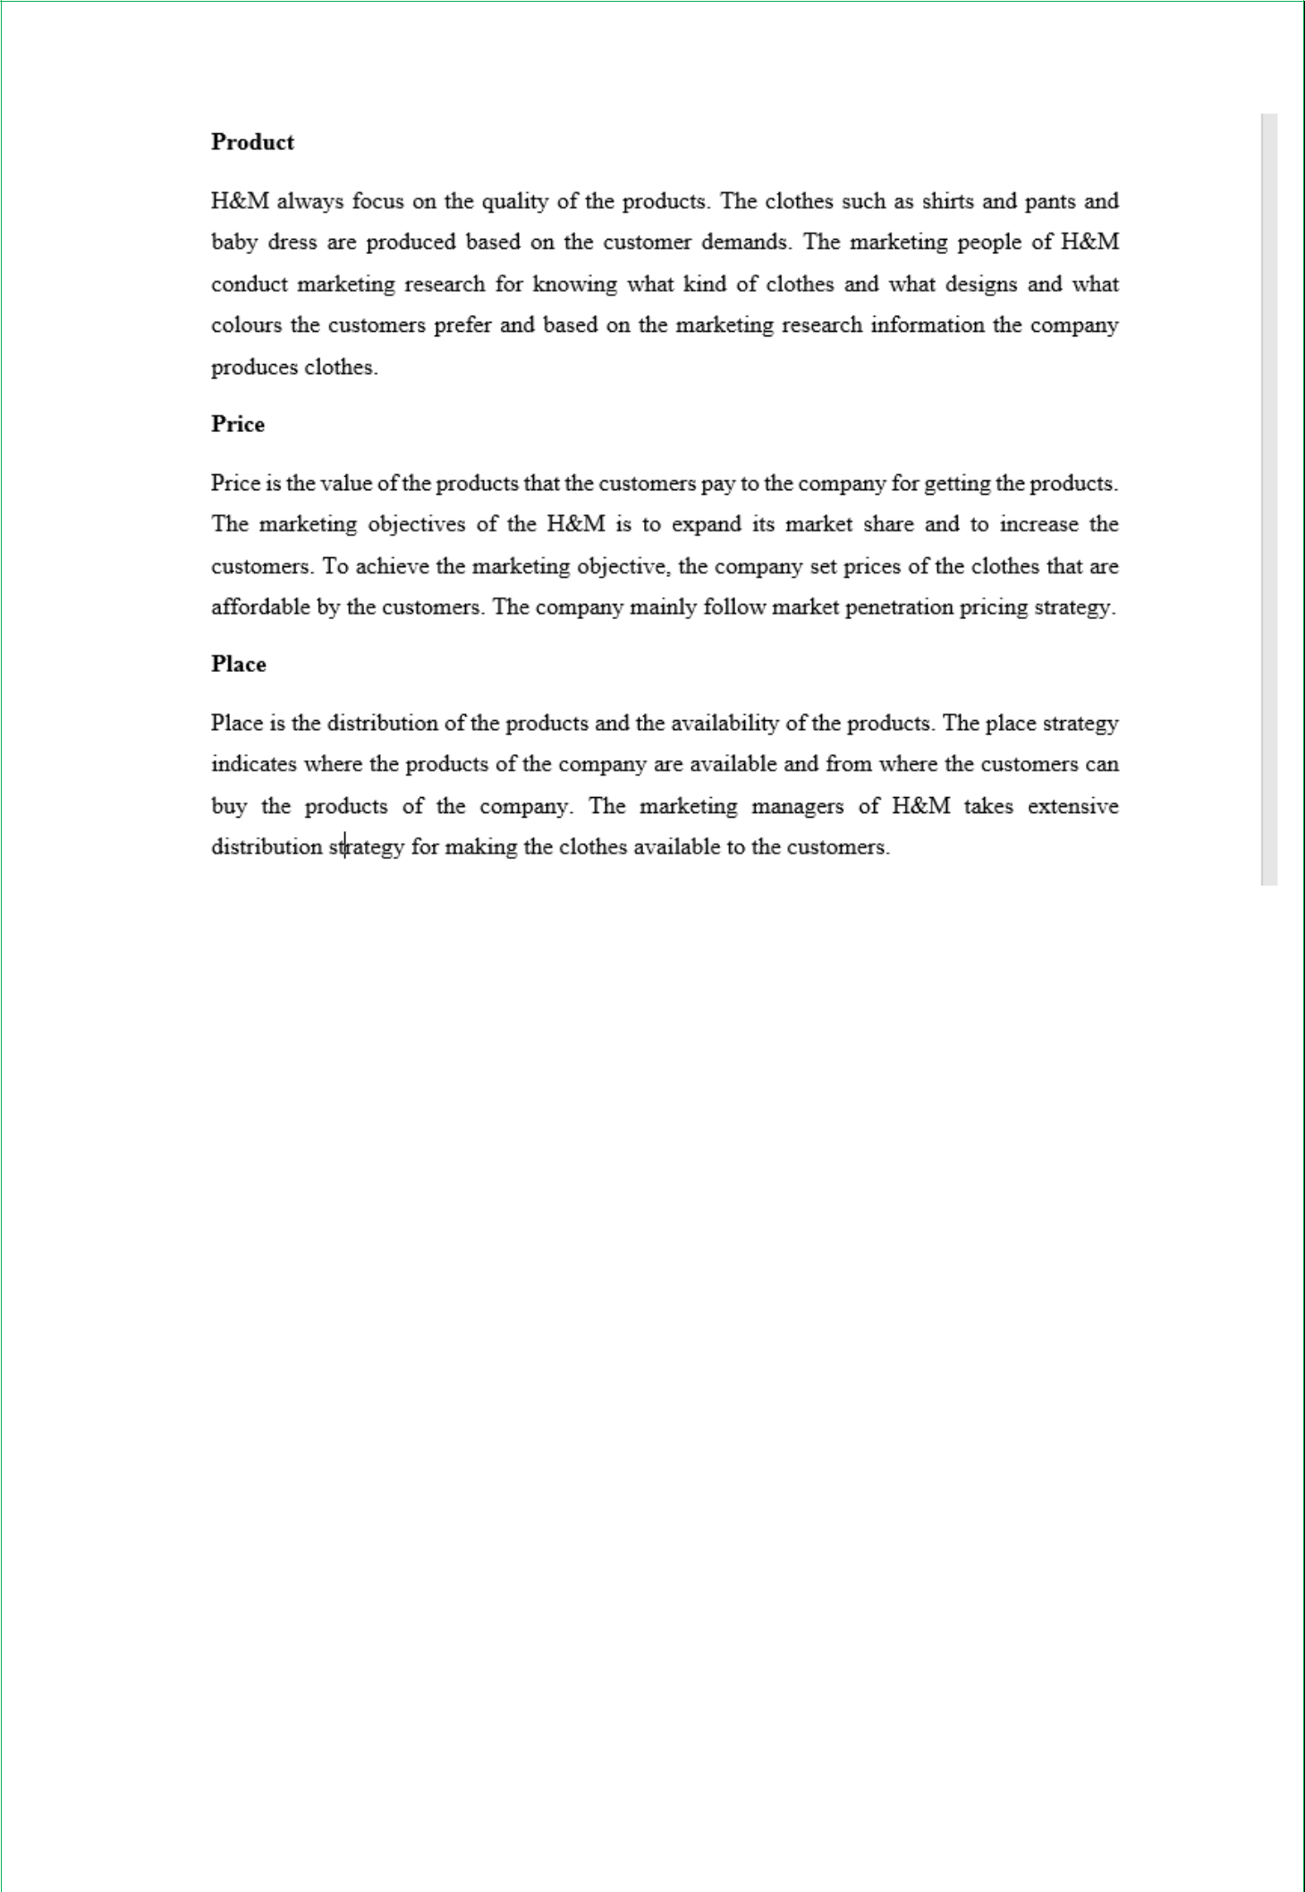

19

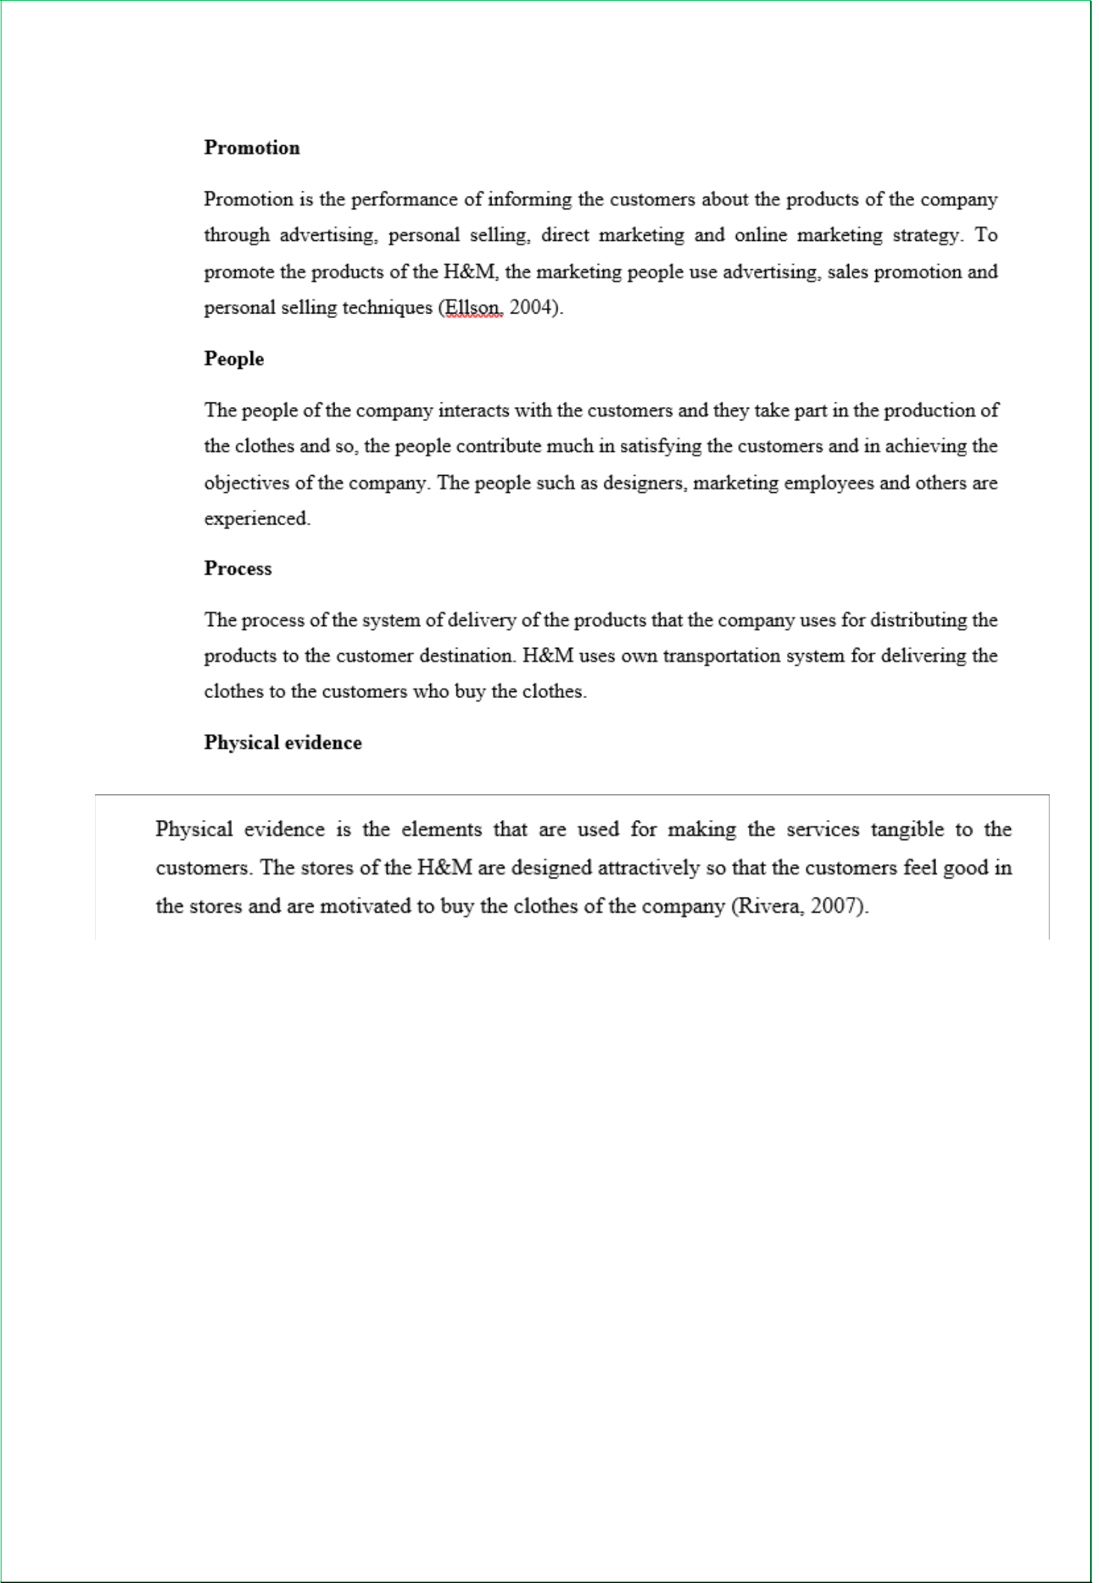

Identification of the sales channels

The marketing plan of H&M identifies the sales channels through which the products of the company are sold to the customers. The sales channels of the H&M are retailing, wholesaling, sales force and tele marketing.

- Retail: The retailers of H&M sell the clothes directly to customers. The sales forces directly or indirectly communicate and present the clothes to the customers and sell the products. The customers are called over the telephone and are induced to buy the clothes of the H&M.

20

- Wholesaling & Sales froce: Sometimes H&M also provide lots of their products services to different places through wholesaling. Thay have several distributors involved in the wholesaling process inside & outside of UK.

- Telemarketing: H&M is formulating several selling processes through different types of online mediums like telemarketing, online sales etc. to grab & reach huge customers.
Tracking the marketing activities

- The marketing activities such as advertising, sponsorship, preparing budget and community building. The marketing plan of H&M determines the marketing activities.

- Advertising and sponsorship

- Advertising and sponsorship activities are done for the promotion of the clothes of H&M. TV commercials and radio advertisement can be used for the products of H&M. The company can sponsor in different events like world cup cricket or any local tournament.

- Community building

- The marketing plan also contributes in developing community with the customers who use the clothes of H&M. The product users of the H&M build community in facebook
and this contributes to create brand positioning in the market.

Evaluation of the marketing plan of H&M:

It is required to evaluate the performance of the marketing employees for understanding whether the marketing objectives are being achieved or not. The marketing managers of the H&M use different techniques for evaluating the performance of the employees who are engaged in implementing the marketing plan. The techniques are the sales analysis, market share analysis and cost-profitability analysis (Ravenscroft, 2012).

- Monitoring Sales: H&M is trying their best to monitoring the overall, sales activity very clearly so that any necessary actin may need to undertake to improve the overall sales activities.

- Sales analysis technique: The sales analysis shows that the marketing activities are being performed according to the marketing plan of H&M. The sales of the H&M have been increased by 15% than the last month sales and this means that the marketing plan is being executed in the right ways.

21

- Market share analysis technique: Market share analysis of the company also shows that the employees are performing better for achieving the marketing plan objectives of H&M. The market share of H&M has been increased by 5% in the clothe industry of
UK and this means that the marketing is properly being executed.

Summary

It can be summarized that the marketing plan of H&M contributes to perform the functions in the right ways and to achieve the marketing and overall the business objectives of the H&M.

22

Conclusion

The marketing activities should be performed properly for achieving the marketing objectives of the company. If the marketing mix strategies are not properly applied and implemented, it is not possible for the organization to reach to its goals and objectives. The marketing plan contributes to achieve the goals in the right ways.

23

References

Botin, J. (2009). Sustainable management of mining operations. 1st ed. Littleton, Colo.:

Published by Society for Mining, Metallurgy, and Exploration.

Carothers, T. (2011). Aiding Democracy Abroad. 1st ed. Washington, D.C.: Brookings Institution Press.

Dawkins, S. (2007) Management accounting decision management. Oxford: Elsevier.

Díaz-Maggioli, G. (2004) Teacher-centered professional development. Alexandria, Va.:

Association for Supervision and Curriculum Development.

Eddy, P. (2014). Connecting learning across the institution. San Francisco, California: Jossey-Bass.

Ellson, T. (2004). Culture and positioning as determinants of strategy. Houndmills, Basingstoke, Hampshire: Palgrave Macmillan.

Franklin, E. (2013). Off the Trails. 1st ed. Newburyport: Open Road Media.

Haldar, U. (2010). Human resource development. 1st ed. New Delhi: Oxford University Press.

Kolb, A. and Kolb, D. (2013). Kolb learning style inventory. 1st ed. [Boston, MA]: HayGroup.

McGuire, D. (2014). Human Resource Development. 1st ed. London: SAGE Publications.

Ravenscroft, A. (2012). 21st century learning for 21st century skills. 1st ed. Berlin: Springer.

Rayner, S. and Cools, E. (2012). Style Differences in Cognition, Learning, and Management.

1st ed. Hoboken: Taylor and Francis.

Reeves, D. (2010) Transforming professional development into student results. Alexandria, Va.: ASCD.

Rivera, C. (2007) Time management. ChandniChowk, Delhi: Global Media.

Rouse, K. (2009) Personal development. South Melbourne: Oxford University Press

24

25

